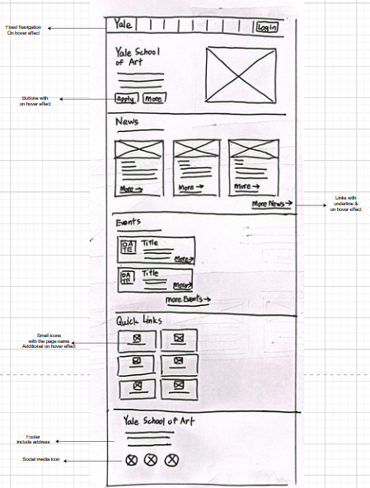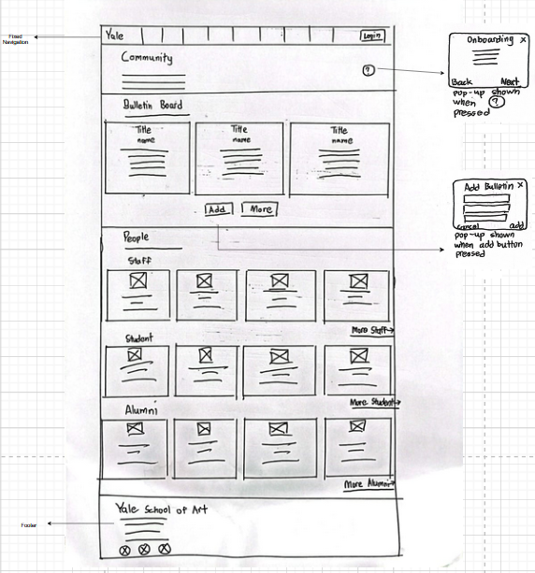
Usability Goal | Design Guidelines | Justification
Learnability | Affordances | Hover feedback immediately tells users which items are clickable. Places that are suitable for this guideline are buttons and links. Faster first-time exploration.
 | Minimalist | The “add bulletin” functions are hidden until the user clicks the button. Reducing the cognitive load of users that doesn’t want to add bulletins.  The Home page information is also less, leaving only necessary or few examples (like 3 news with “read more” links) information.
 | Gestalt Principle  Similarity | Identical card structure at news, people and bulletin section. After users learnt the card pattern, they can also how the following cards work for that same group of section
 | Gestalt Principle  Common region | Each section are divided and will apply with different suitable background colour.  At community page, switching 3 card block to 4 card block also can act as a silent boundary. Allowing user to know they are in next section.
 | Jakob Neilson  Help and Documentation | A small tooltips at Community page allow new user to know directly what exact things to do
Memorability | Jakob Neilson  Matches between system and real world | Icon metaphors are used in quick links and footer’s social media links. Allowing users to easily recognize where the button will bring user to
 | Jakob Neilson  Recognition over recall | Quick links surface the most visited pages of the website. User don’t have to remember the exact location of the page; they just need to know the page name.
 | Card/Block Layout | Cards layouts are suitable to show things that have multiple sub-pieces information. Card boundary can clearly group one instances together without mixing them with other instances.

